Walkthrough 20 Aggregation Binding

https://sapui5.hana.ondemand.com/#/topic/bf71375454654b44af01379a3c3a6273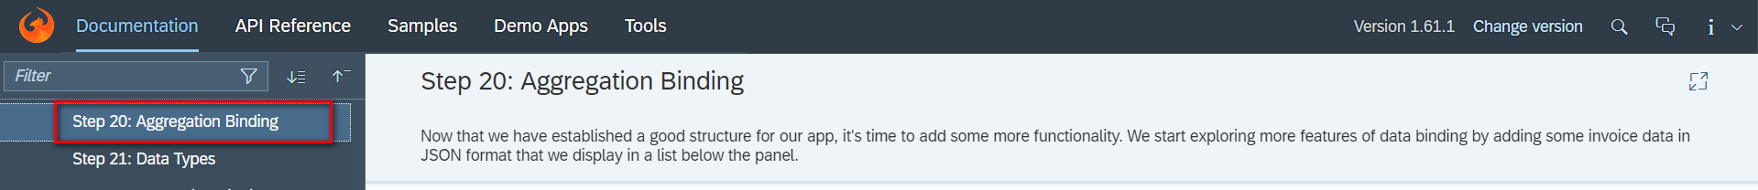

Core Changed Codes Compared to Last Version:

准备本地静态JSON格式数据 Invoices.json

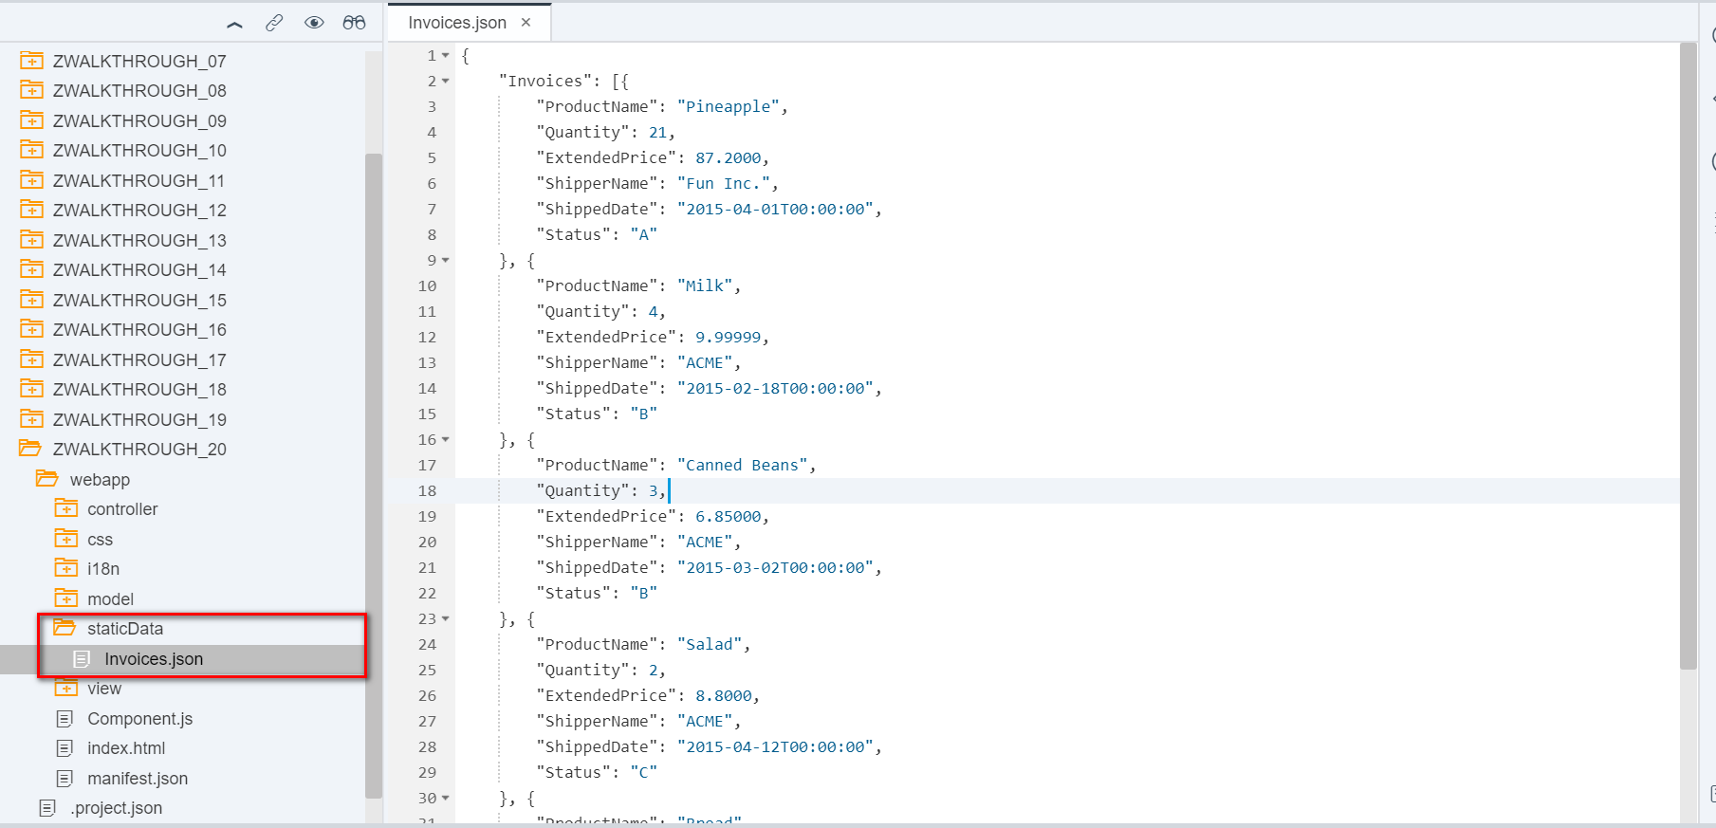

初始化JSON模型 manifest.json

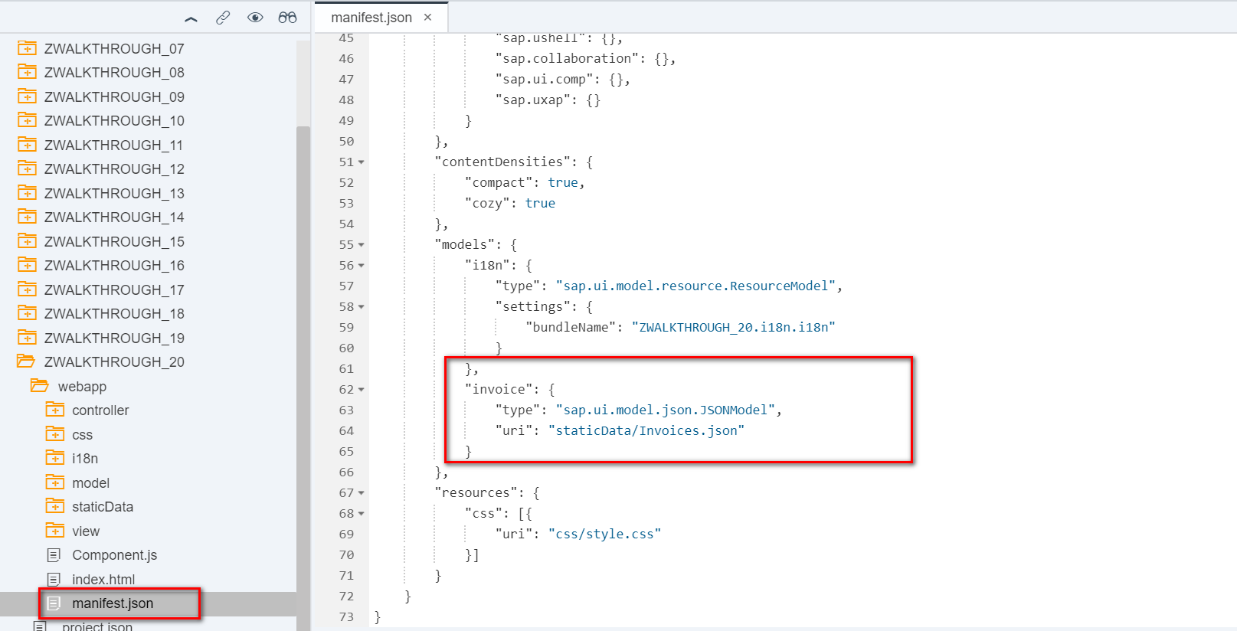

新建列表视图显示invoice内容 Invoice.view.xml

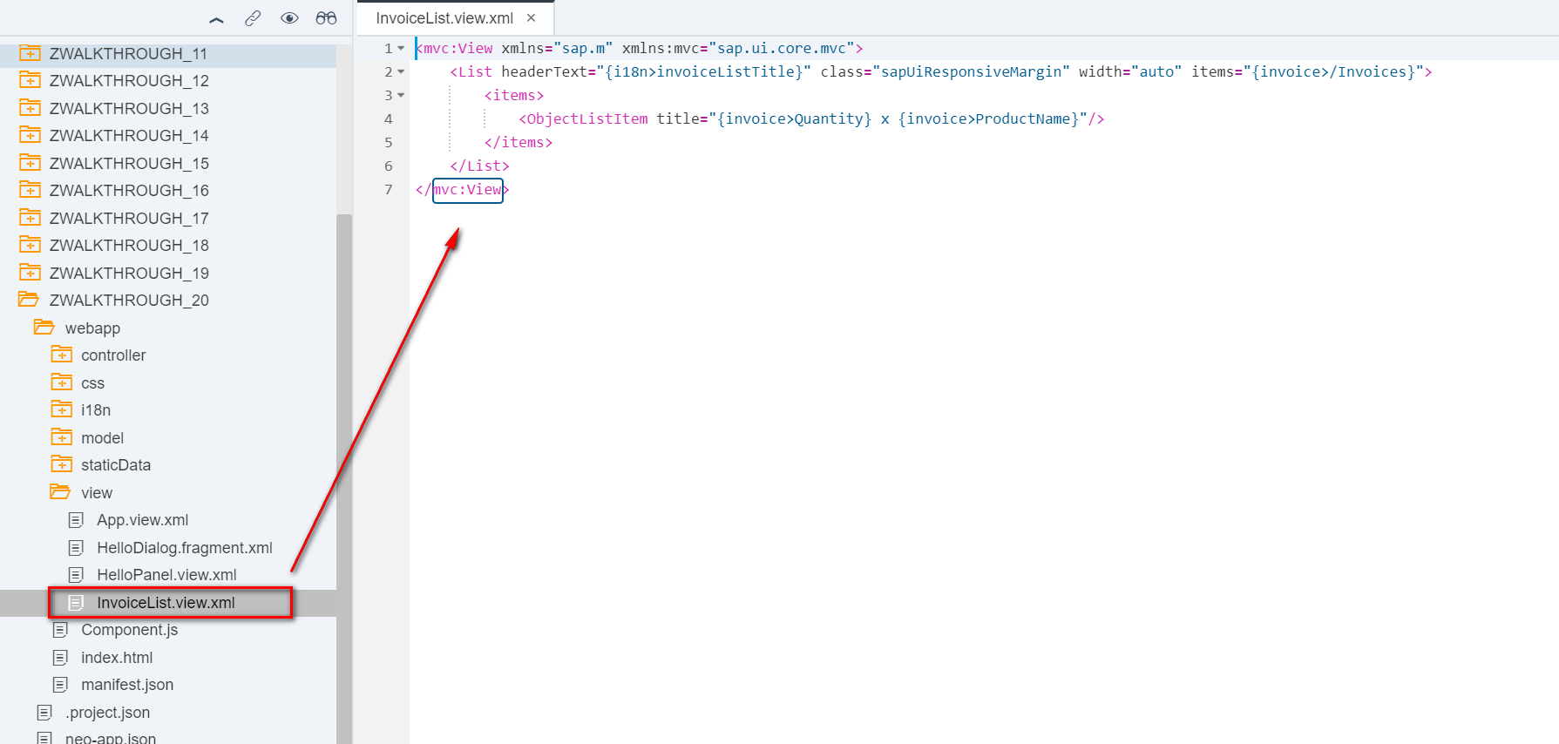

将列表添加至初始视图App.view.xml

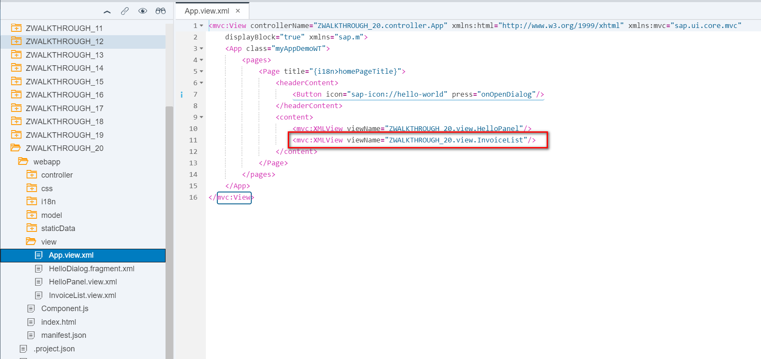

文本对象统一管理i18n

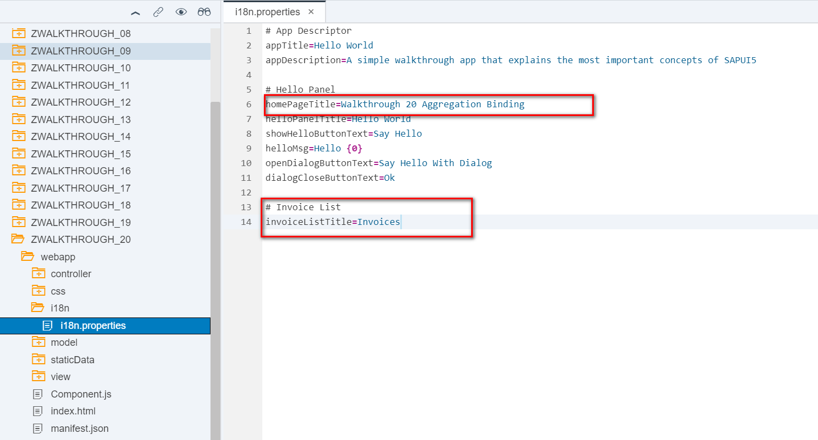结果

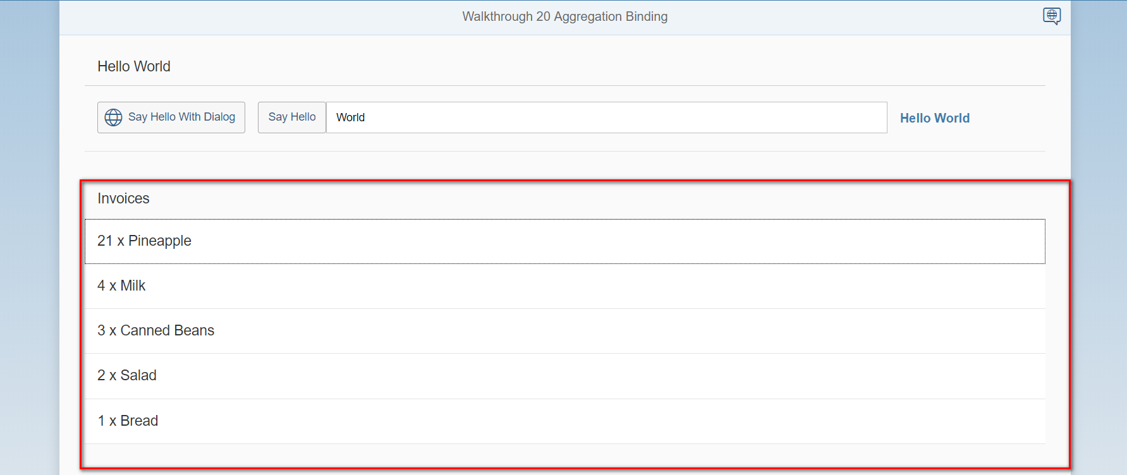

Git:

https://github.com/xiexiaop/SAPUI5-2-Round/tree/master/Projects/ZWALKTHROUGH_20

2019/02/01 XiaoMi Beijing Zac,Xie